**UNIVERSITY OF PUNJAB BA ENGLISH PAPER-B GROUP 2 2016**

**English Language B.A 2016 University Punjab**

Time Allowed: 3 Hrs. PAPER: B Max.Marks: 100

**Group II**

**IMPORTANT NOTE:** Over attempted idioms/correction of sentences will not be marked. Only the First FIVE will be marked. Don’t write your names, Ph# or identity in any answer.

**Question # 1**

Write an essay with outline of 300-350 words on one of the following topics: (20+5)  
(1) Domestic Violence Against Women  
(2) How can we build the soft image of Pakistan  
(3) Provision of justice can strengthen democracy  
(4) Pakistan: An emerging economy  
(5) Democracy: The only way forward in the contemporary world

**Question # 2**

Read the following passage and answer the questions at the end. The answer must be in your own words. (10+15)  
As we survey the whole course of man’s development from the earliest times to the present and from the most primitive and simple to the most complex way of living, we are strongly impressed by the fact that whatever men have lived together there has been some group interest in education. As the group beconles more complex than this interest grows, institutions definitely charged with the task of teaching are created. Thus the school comes into existence and an educational system evolves.  
But so far as we know from the meagre records which have been left, early man had only a very simple educational system. Most of the child’s learning was picked up as he associated with his parents and other members of the family, tribe, clan, or larger group. He learned to fish and to prepare his food, to fight his enemies and to take care of his simple and elementary needs. In short, he learnt to survive on the world in which he found himself.  
As the life of group became more complex, certain number of the groups took it upon themselves to become thoroughly familiar with the traditions and the customs and devoted most of their time to teaching of the young. At first, this teaching was done wherever the teacherand a group of learners cared together. But later specified places for teaching and learning were set up. These were the first schools.  
Questions:  
(a) How can we say that even the earliest man had interest in education?  
(b) How and when was the first educational institution established?  
(c) What kind of educational system did the early men have?  
(d) Trace the development of educational system?  
(e) Suggest a suitable title for the passage?  
(f) Make a precis of the passage.

**Question # 3**

Write a letter to the D.P.0 of your district regarding the rising tide of sectarian violence in your district. (15)  
OR  
Write an application to the DPO of your district on the rise of drug trafficking in your areas.

**Question # 4**

Correct any five of the followings. (No extra attempt will be marked) (10)  
(1) He gave me many abuses.  
(2) He bought five dozens eggs.  
(3) The English is spoken throughout the world.  
(4) He fixed a gallow for the criminal.  
(5) One must do his duty.  
(6) If he were older, he have more sense.  
(7) One should take care of his health.  
(8) She sing poem to her audience.  
(9) The envy is an evil passion.  
(10) I cannot help to praise him.

**Question # 5**

Use any five of the following phrases in sentences. (No extra attempt will be marked) (10)  
(a) A live wire  
(b) Gift of the gab  
(c) Small Hours  
(d) The eternal triangle  
(e) Point Blank  
(f) To bury the hatchet  
(g) Budding genius  
(h) In cold blood  
(i) A kettle of fish  
(j) Cry up

**Question # 6**

Write a dialogue between two friends on the issue of global warming. (15)  
OR  
Translate the following paragraph into English.

[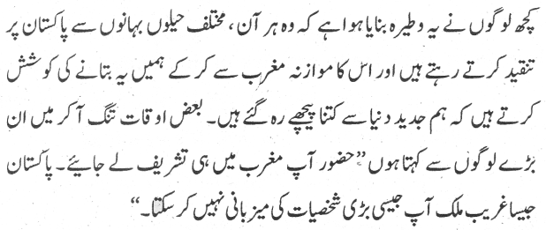](https://i0.wp.com/www.taleem-e-pakistan.com/wp-content/uploads/2020/05/English-Language-2016-Group-2-Paper-B.png?ssl=1)