**UNIVERSITY OF PUNJAB BA ENGLISH PAPER-B 2016**

**English Language B.A 2016 University Punjab**

Time Allowed: 3 Hrs. PAPER: B Max.Marks: 100

**Group I**

**IMPORTANT NOTE:** Over attempted idioms/correction of sentences will not be marked. Only the First FIVE will be marked. Don’t write your names, Ph# or identity in any answer.

**Question # 1**

Write an essay with outline of 300-350 words on one of the following topics: (20+5)  
(1) Sweet are the uses of adversity.  
(2) Overseas Pakistanis: Our informal ambassadors.  
(3) Power corrupts and absolute power corrupts absolutely.  
(4) Role of Women in Nation Building  
(5) Folk Tales of the Punjab

**Question # 2**

Read the following passage and answer the questions at the end. The answer must be in your own words. (10+15)  
It has become a national habit to curse the state for anything that happens in our lives. If there is a breakdown of electricity or traffic jam on the road, it is our favourite pastime to start finding fault with the state. We do not realize how danger is this. By casting doubts on the existence or efficacy of state in solving daily life problems, we are playing in the hands of terrorists. Because their main objective is to make people realize that the state has become a failure. Our media also sometimes cannot maintain the fine balance between criticism and despondency. Pakistan is not a failed state. The people of Pakistan are aware that they have a long journey to cover to make Pakistan a democratic, welfare state. There are a score of political, cultural and social issues that we have to sort out. But nobody should think that the people of Pakistan are not capacitated to do the job. With the help of our strong faith in Allah, our capacities and by building our institutions, we would steer Pakistan out of these hard times. The best example of this resolve can be seen in the operation Zarb-e-Azab when the valiant armed forces of Pakistan, backed by the civilian support, reduced the number of terrorist attacks in Pakistan. And Pakistan is on the way to progress and prosperity.  
Questions:  
(1) What is our favourite pastime in an unusual situation?  
(2) What is the inherent danger in cursing the state?  
(3) What is the narrative of the terrorists?  
(4) How would Pakistan come out of these hard times?  
(5) Suggest some other ways to make Pakistan strong.  
(6) Make a précis

**Question # 3**

Write a letter to the editor of the newspaper about the need for a massive campaign for tree plantation in the country. (15)  
OR  
Write an application to the Health minister of the Punjab for the provision of medical facilities in Government Hospitals of your district.

**Question # 4**

Correct any five of the followings. (No extra attempt will be marked) (10)  
(1) He is a coward.  
(2) He persisted to do it.  
(3) There are lying ten furnitures in your room.  
(4) After all, he had to confide on somebody.  
(5) The girl who was promoted; she was my fiancée.  
(6) His all hopes were dashed to the ground.  
(7) He was failed in B.A.  
(8) The pizza and the sandwich looks good.  
(9) The decreasing number of birth have been attributed to family planning.  
10) He is not capable to do it.

**Question # 5**

Use any five of the following phrases in sentences. (No extra attempt will be marked) (10)  
(a) Bear up  
(b) Go about  
(c) On the horns of dilemma  
(d) Blue stocking  
(e) Throw to the dogs.  
(f) A brown study  
(g) A hard nut to crack  
(h) Blue Blood  
(i) At daggers drawn  
(j) Cast a slur

**Question # 6**

Write a dialogue between two friends on the harms of child labour. (15)  
OR

[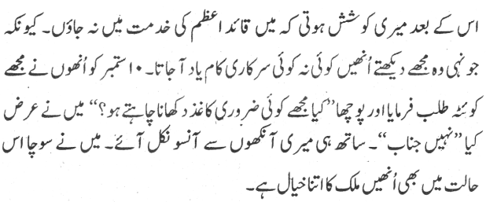](https://i0.wp.com/www.taleem-e-pakistan.com/wp-content/uploads/2020/05/English-Language-2016-Group-1-Paper-B.png?ssl=1)